The Hellenic-American Oral History Project: Greek Americans, launched January 24, 2013.
Documenting the Greek Diaspora in Astoria, New York, the largest Hellenic-American community in the United States
---------------------------------------------
Greek Immigration in the United States—A Historical Overview
Massive Greek immigration to the United States did not occur until the twentieth century. The first massive wave took place between 1900 and 1924 and a second, smaller wave took place between 1965 and 1980. Graph 1 presents an overview of Greek immigration to the U.S. from 1890 to 2010, based on data from the U.S. Census.
Graph 1.
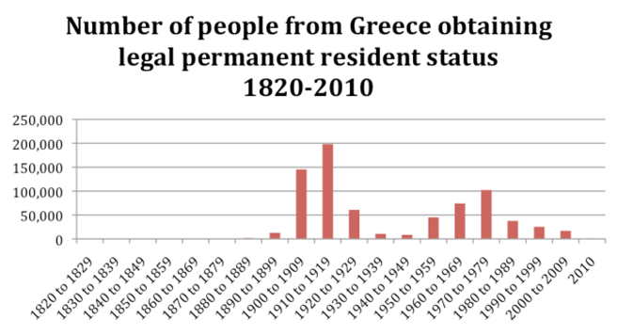
The first wave was part of the Great Migration from Europe that began in the 1880s when cheap manual labor was needed in America and convenient immigration legislation encouraged that migration. Greeks were among the last of the Europeans to immigrate to America during the Great Migration, and their numbers are relatively small when compared to neighboring nations of Southern Europe, like Italy, for example.
Immigration and Naturalization Services data provide documentation that about 421,000 Greeks immigrated to the United States between 1890 and 19211. Their pattern of settlement shows that the vast majority settled on the East Coast, primarily Florida and New York, and the industrial Midwest, in Chicago, Detroit, or Pittsburgh2.In addition, they also formed enclaves on the West Coast since they worked in the lumber, mining, and construction industries. However, anti-immigration laws passed in the early twentieth century resulted in four decades of declining Greek immigration to the United States3.
The second wave took place in the years 1965 to 1980, as a result of the Hart-Heller Act that removed ethnic quotas. Although the numbers of that period did not reach the peak of the earlier period, about 200,000 Greeks entered the United States, showing a settlement pattern favoring the large urban centers.
Since the mid-1980s there has been no other wave of immigration from Greece, basically due to improving economic conditions that culminated with Greece’s admission to the European Union. The number of immigrants has hovered at one to two thousand annually, with almost an equal number returning to Greece4.
However, due to the economic crisis in the beginning of the twenty-first century, which is evident in the countries of the European Union, and Greece in particular, it is possible there will be another wave of immigration to the United States.
The abolition of discriminatory laws by the 1965 Immigration Act not only contributed to another wave of immigration from Southern and Eastern Europe, but also ignited a mass influx of immigrants from Asia and other non-European countries. Indeed, between 1965 and 2000 more than twenty-eight million immigrants entered the United States, the overwhelming majority of them (more than 85 percent) from non-European countries. More specifically, from all the post-1965 immigrants, about 25 percent originated from Asian countries5, 60 percent from other countries, and only 15 percent from Europe. Therefore, although post-1965 immigration to the U.S. is overwhelmingly non-European, Greece was the only European country to produce another numerically noticeable mass immigration wave in this period. As a result, Greek Americans revitalized their ethnic populations, while many new Asian and Hispanic ethnic groups emerged. The influx of Greek immigrants since the 1960s has expanded the Greek population in the United States from fewer than one million in 1970 to about 1.3 million Americans who state they have some Greek ancestry6 in 2000. The most striking demographic characteristic of this current Greek American population is that the number of the American born of full Greek parentage is double the number of the immigrant group: 400,000 to 200,000, respectively. As far as concerns the remaining 500,000 Greek Americans, 200,000 have at least one Greek immigrant grandparent and 300,000 are of mixed parentage.
The post-1965 immigrants showed residential patterns similar to the earlier Greek immigrants; Greek Americans are dispersed throughout the United States but they have settled in large urban cities. Various Greek ethnic communities have been established on the West Coast (California, Portland) and in the industrial Midwest (Chicago, Detroit, Pittsburgh). However, the vast majority settled on the East Coast (primarily Florida and New York).
The Greek American Population of New York
Traditionally, Greek Americans have been concentrated in New York. It has been well documented that New York has been a preferable place of initial disembarkation and permanent settlement since the early period of Greek mass immigration to the United States, slightly over a hundred years ago. A scholar writes in the early 1900s, “New York was their first settling place. They settled by hundreds in the city.”7 And later in the 1980s another scholar states that
the 1970 census shows that the primacy of New York State in terms of number of Greeks continues from the early days. Approximately one in four of all Greek Americans resides in the Empire State. Illinois is second in the number of Greeks, followed by California, Massachusetts, and New Jersey.8
Greeks have inhabited the Astoria section of Queens, New York, during the second wave of mass immigration (1965-1980), and it has been considered the largest Hellenic settlement outside of Greece or Cyprus.
The Greek Population of New York City Today
According to the last census, it is evident that the Greek American community of New York is undergoing a cyclical change, as the original post-1965 immigrants have achieved residential mobility and have moved out of Astoria. They have established satellite communities in the nearby semi-suburban areas of Queens, such as Bayside and Whitestone. In this respect, it is of major sociological interest to examine to what extent post-1965 ethnic groups maintain their ethnic identity and attachment.
This present research project attempts to document the level of ethnic attachment among first and second generation Greek Americans as a case of the new post-1965 generations of Southern European immigrants in the United States. Social scientists consider ethnic attachment as a major indicator of the degree to which members of an ethnic or immigrant group are integrated into the ethnic community in three possible levels: culturally, socially, and psychologically.
Although since the late 1980s social research on the “new second generation” has increased significantly, not much scholarly work has been done on second generation Greeks. In this respect, the sociological analysis of Greek immigration to the US remains incomplete. The findings of this research are important to Greek American sociological literature and Greek American studies in general since they provide new knowledge on a group that has, so far, not been studied adequately.
Demographics – Greek Americans of New York City
According to official estimates, New York Greek Americans show an equal sex ratio: 50% males to 50% females. This is an interesting characteristic since the traditional pattern of Greek immigration, similar to other immigrant groups in America, was predominately male immigration. The median age (39 years old) is slightly higher than the national level (37 years old). At the same time, the percentage of 17-year-old and younger Greek Americans (23) is close to the national average (24). Also, the average family size of three members is similar for New York and the rest of the country, while fertility rates are slightly higher for New York Greek Americans (6.6%), when compared to the national rate of about 5%.
Table 1: Demographic characteristics, Greek Americans, NY - 2008-2011 estimates
 |  |  | United States |  |  | NY Metropolitan Area
 |  |  | All | Greek Ancestry |  | All | Greek Ancestry
 | Total Population |  | 303,231,244 | 1,311,844 |  | 18,911,903 | 178,966
 | % Men |  | 49.2 | 50.2 |  | 48.2 | 49.9
 | Median age |  | 37.2 | 37.2 |  | 37.6 | 39.1
 | % 17 & under |  | 23.9 | 24.2 |  | 22.8 | 23.2
 | Average family size |  | 3.21 | 3.11 |  | 3.37 | 3.27
 | Total
Source: U.S. Census Bureau, 2008-2011 American Community Survey

Table 1.1: Sex, Age, Fertility Rates – Greek NY
 |  |  | United States |  |  | New York City
 |  |  | All | Greek Ancestry |  | All | Greek Ancestry
 | Men |  | 49.3% | 50.2% |  | 47.7% | 49.0%
 | Women |  | 50.7% | 49.7% |  | 53.3% | 51.0%
 | Median age |  | 36.7 | 36.1 |  | 35.7 | 40.1
 | 17 & under |  | 24.4% | 25.6% |  | 22.7% | 19.5%
 | Fertility Rates |  | 5.6 | 4.7 |  | 5.1 | 6.6
 | Total |  |  | 1,370,809 |  |  | 83,779
Source: U.S. Census Bureau, 2008-2011 American Community Survey
Native vs. Foreign-Born Greek
The native-born population of the United States reaches up to 87%, which is identical to the overall native-born Americans of Greek ancestry. For New York, it is of great interest that the American-born Greek population is 66%, in comparison to 34% of foreign-born Greek Americans. This is an indication of a significant transformation of the group, since it supports that the post-1965 Greeks are beyond the immigrant generation. Greek Americans are no longer an immigrant group, but an American ethnic group. Greeks are now Americans of a certain ethnic background. Of the foreign-born, Greek males have higher rates of naturalization (52%) than females (48%).
On the national level, the majority of Greek Americans speak only English at home (73%), while for New York the rate is as low as 35%. This finding supports our hypothesis that the Greek American community still has a strong cultural attachment, with lower cultural assimilation rates than Greek Americans in the rest of the United States. A sociological explanation of this is the fact that New York has received the majority of the post-1965 immigrants, who replenish the Greek population of the area.
Table 2: Demographics – Native and Foreign Born – Greek NY
 |  |  | United States |  |  | New York City
 |  |  | All | Greek Ancestry |  | All | Greek Ancestry
 | Total |  | 304,320,460 | 1,370,809 |  | 8,349,630 | 83,779
 | Native born |  | 266,230,290 (87.5%) | 1,200,826 (87.6%) |  | 5,346,232  (64%) | 55,233  (65.9%)
 | Foreign born |  | 38,090,166 (12.5%) | 169,983  (12.4%) |  | 3,003,398  (36%) | 28,546  (34.1%)
 | Percent men |  | 50.2% | 54.4% |  | 47.5% | 58.6%
 | Foreign born naturalized |  | 16,343,118 (42.9%) | 131,760  (77.5%) |  | 1,543,467 (51.4%) | 22,127  (77.5%)
 | Percent men |  | 46.4% | 53.6% |  | 44.4% | 52.1%
 | Speak only English at home |  | 80.2% | 73.3% |  | 52.6% | 35.1%
 | Speak English less than well |  | 8.6% | 6.7% |  | 23.2% | 21.8%
Source: U.S. Census Bureau, 2008-2011 American Community Survey

Households by Type
Overall, family households rates are slightly lower for New York Greeks (62%) than the national levels (64%). In addition, Greek male householders show a similarity on national and local levels of almost 18%, while females have a slightly higher percentage of 20.5%.
Table 3: Households by Type – Greek NY
 |  |  | United States |  |  | New York City
 |  |  | All | Greek Ancestry |  | All | Greek Ancestry
 | Number of households |  | 113,104,064 | 510,287 |  | 3,057,132 | 33,519
 | Family households |  | 66.5% | 63.8% |  | 59.9% | 61.9%
 | Male householder (no spouse) |  | 15.6% | 17.7% |  | 17.7% | 17.6%
 | Male householder living alone |  | 12.1% | 13.7% |  | 14.0% | 14.5%
 | Female householder (no spouse) |  | 18.0% | 18.5% |  | 22.3% | 20.5%
 | Female householder living alone |  | 15.3% | 15.2% |  | 19.4% | 17.7%
Source: U.S. Census Bureau, 2008-2011 American Community Survey
Marital Status
Married couple families reach a high rate of 80%, and it is similar on the national and local levels. Married Greek Americans in NY have a rate of 53%, slightly higher than the national average of 50%. Married males show a percentage of 37%. On the other hand, Greeks show slightly lower divorce/separation rates.
Table 4: Marital Status – Greek NY
 |  |  | United States |  |  | New York City
 |  |  | All | Greek Ancestry |  | All | Greek Ancestry
 | Married |  | 49.7% | 49.9% |  | 39.9% | 53.3%
 | -Percent male |  | 51.7% | 51.8% |  | 43.6% | 36.6%
 | Widowed |  | 7.3% | 5.4% |  | 7.3% | 6.8%
 | -Percent male |  | 2.5% | 2.2% |  | 2.4% | 2.5%
 | Divorced |  | 10.6% | 8.3% |  | 8.0% | 6.7%
 | -Percent male |  | 9.3% | 8.3% |  | 6.3% | 6.8%
 | Separated |  | 2.2% | 1.4% |  | 3.7% | 2.0%
 | -Percent male |  | 1.8% | 1.2% |  | 2.7% | .9%
 | Never married |  | 31.4% | 33.8% |  | 42.2% | 32.0%
 | -Percent male |  | 34.7% | 36.5% |  | 45.0% | 36.1%
 | Male householders (no spouse) |  | 6.9% | 6.5% |  | 9.0% | 6.1%
 | Female householders (no spouse) |  | 18.8% | 13.9% |  | 30.3% | 14.3%
 | Married couple families (as percentage of households) |  | 74.2% | 79.6% |  | 60.7% | 79.6%
Source: U.S. Census Bureau, 2008-2011 American Community Survey
Higher Education
Traditionally, Greek Americans value education, and the census figures support this. Greek Americans are more likely to have a college education or higher, and it is Greek American women in New York City who show the highest percentage (42%).
Table 5: Higher Education – Greek NY
 |  |  | United States |  |  |  |  | New York City
 |  |  | All |  | Greek Ancestry |  |  | All |  | Greek Ancestry
 |  |  | Men | Women | Men | Women |  | Men | Women | Men | Women
 | % enrolled in college |  | 23.8 | 29.8 | 27.2 | 33.1 |  | 25.0 | 33.0 | 26.4 | 31.8
 | % Bachelor’s degree or higher |  | 28.4 | 27.2 | 40.7 | 37.6 |  | 33.7 | 33.5 | 38.7 | 41.6
Source: U.S. Census Bureau, 2008-2011 American Community Survey
Employment
More than the two-thirds of Greek Americans are in the labor force, for both New York City and the national level, and high employment rates also hold true for women in New York City (51%) when compared to the national level of 57%, or the overall American level of 55%.
Table 6: Employment – Greek NY
 |  |  | United States |  |  | New York City
 |  |  | All | Greek Ancestry |  | All | Greek Ancestry
 | In labor force |  | 65.3% | 66.9% |  | 63.4% | 61.3%
 | Employed |  | 55.1% | 56.8% |  | 58.2% | 56.7%
 | Unemployed |  | 4.3% | 4.0% |  | 5.2% | 4.5%
 | Women in labor force |  | 59.5% | 61.0% |  | 57.6% | 54.4%
 | -Employed |  | 55.1% | 56.8% |  | 53.0% | 51.0%
 | -Unemployed |  | 4.3% | 4.0% |  | 4.6% | 3.4%
Source: U.S. Census Bureau, 2008-2011 American Community Survey
Income
Overall, Greek Americans show a higher median income or average earnings than the general population on both the national and local levels.
Table 7: Income – Greek NY
 |  |  | United States |  |  | New York City
 |  |  | All | Greek Ancestry |  | All | Greek Ancestry
 | Households
 | Median income |  | 51,369 | 63,872 |  | 50,512 | 68,349
 | Mean earnings |  | 71,279 | 90,829 |  | 73,523 | 86,211
 | Families
 | Median income |  | 62,367 | 79,635 |  | 55,495 | 79,103
 | Married couple median income |  | 74,015 | 90,388 |  | 73,523 | 86,211
 | Male householder median income |  | 43,280 | 54,772 |  | 48,765 | 57,031
 | Female householder median income |  | 30,524 | 41,186 |  | 32,348 | 51,675
 | Individual median earnings by sex
 | Male |  | 45,320 | 58,121 |  | 44,634 | 59,930
 | Female |  | 35,299 | 43,197 |  | 41,456 | 52,500
Source: U.S. Census Bureau, 2008-2011 American Community Survey
Industry of Employment
Greek Americans are represented in many different industries. Greek Americans in New York City are concentrated in education/health care (24%), followed by professional/scientific (12%), and the construction industry and the arts (10%). (We should note that the American Community Survey did not include the category of food services.)
Table 8: Industry of Employment (percent) – Greek NY
 |  |  | United States |  |  | New York City
 |  |  | All | Greek Ancestry |  | All | Greek Ancestry
 | Agriculture, forestry, fishing |  | 0.1 | 0 |  | 0.1 | 0
 | Construction |  | 7.3 | 6.5 |  | 5.4 | 10.3
 | Manufacturing |  | 11.0 | 8.0 |  | 4.4 | 5.6
 | Wholesale |  | 3.0 | 3.0 |  | 2.7 | 2.7
 | Retail |  | 11.5 | 11.3 |  | 9.5 | 8.4
 | Transportation |  | 5.1 | 3.9 |  | 6.3 | 3.2
 | Information |  | 2.4 | 2.9 |  | 4.0 | 4.9
 | F.I.R.E |  | 7.0 | 9.2 |  | 10.5 | 12.6
 | Professional, scientific |  | 10.5 | 11.5 |  | 12.4 | 12.1
 | Ed, health care |  | 21.8 | 21.0 |  | 25.5 | 24.1
 | Arts |  | 8.9 | 13.4 |  | 9.7 | 9.9
 | Other services, not  public administration |  | 4.9 | 4.7 |  | 5.6 | 3.3
 | Public administration |  | 4.7 | 4.1 |  | 4.2 | 2.8
Source: U.S. Census Bureau, 2008-2011 American Community Survey
Poverty
Overall, there are significant differences in poverty rates between Greek Americans and the general population at both the national and local levels. Greek Americans in New York City have a lower level of poverty in all categories. The only category with a high poverty level is for the 65+, senior citizens group, perhaps because of their work in the informal sector of the economy.
Table 9: Poverty – Greek NY
 |  |  | United States |  |  | New York City
 |  |  | All | Greek Ancestry |  | All | Greek Ancestry
 | All families |  | 9.9% | 5.7% |  | 15.5% | 7.4%
 | Families w/children under 18 |  | 15.5 | 8.1 |  | 22.3 | 7.2
 | Families w/children under 5 |  | 16.9 | 8.5 |  | 16.8 | N
 | Married couple families |  | 4.8 | 2.8 |  | 8.9 | 5.3
 | With children under 18 |  | 6.8 | 2.9 |  | 11.6 | 2.9
 | With children under 5 |  | 6.3 | 2.6 |  | 9.1 | N
 | Female households no spouse |  | 28.6 | 20.1 |  | 29.3 | 16.5
 | With children under 18 |  | 37.1 | 28.1 |  | 39.0 | 29.9
 | With children under 5 |  | 45.4 | 33.0 |  | 35.9 | N
 | All people |  | 13.6 | 8.3 |  | 18.5 | 8.0
 | Under 18 |  | 18.9 | 8.0 |  | 27.2 | 5.5
 | 65+ |  | 9.7 | 8.2 |  | 18.3 | 11.9
Source: U.S. Census Bureau, 2008-2011 American Community Survey
Footnotes
1. Immigration and Naturalization Services, Annual Report, 1976.
2. Dan Georgakas, Greek America at Work (NY: Greek American Labor Council, 1992).
3. Between 1930 and 1965 a large number of Greeks who immigrated to the US carried Ottoman, Italian, or British passports, so it is likely that the total number of immigrants in the first forty years of the century is between 600,000 and a million.
4. Dan Georgakas, “Now and Future Greek America,” JMH, No. 21-22, p. 13: “Greeks had among the highest return rates of all European immigrants, at least 25%, and perhaps as high as 50%.”
5. Pyong Gap Min, Second Generation Ethnic Identity among Asian Americans, p. 2.
6. US Census, 2000.
7. Thomas Burgess, Greeks in America (New York: Arno Press, 1970; originally published in Boston, 1913). In an article by Eva E. Sandis “The Greek Population of New York City,” 65.
8. Eva Sandis, 70.
References

Alexiou, Nicholas. The State of Greek American Assimilation: Towards Symbolic thnicity, Journal of Modern Hellenism, No. 10, 1993: 37-58.
----- Religious and Ethnic Identities, Theory in Action, Vol. 2, No. 4, October 2009: 77-85.
----- Romaniote Jews in the United States, Journal of Modern Hellenism, No. 23-24, 2006-2007: 171-181.
Burgess, Thomas. Greeks in America (NY: Arno Press, 1970; originally published in Boston, 1913).
Georgakas, Dan. Greek America at Work. NY: Greek American Labor Council, 1992.
----- Now and Future Greek America, JMH, No. 21-22.
Kourvetaris, George. Studies on Greek Americans. East European Monographs, 1997.
Moskos, Charles. Greek Americans: Struggle and Success. Transaction Publishers, 1989/1980.
Min, Pyong Gap. Second Generation: Ethnic Identity among Asian Americans. NY: Altamira Press, 2002.
Sandis, Eva. The Greek Population of New York City; in The Greek American Community in Transition. Ed. by Harry Psomiades and Alice Scourby. NY: Pella Publishing, 1982
Saloutos, Theodore. The Greeks in the United States. Harvard University Press, 1964.
Appendix A.
A graphical depiction of residential transformation of the Greek Americans in Queens, NY.
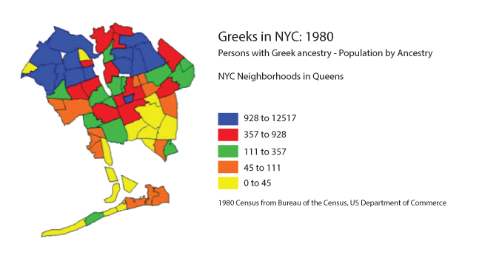
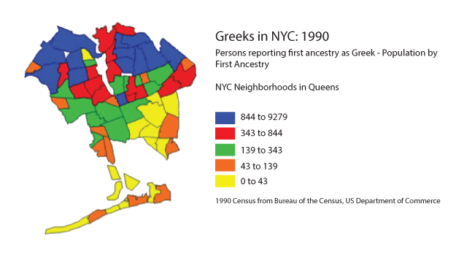
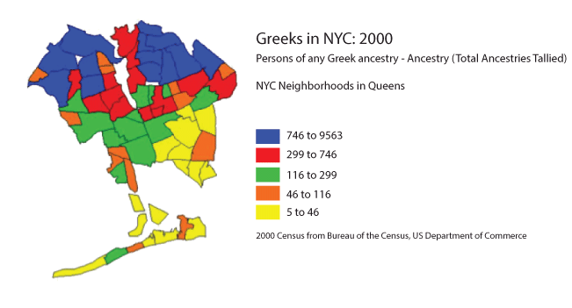

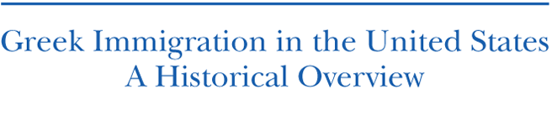
by
Nicholas Alexiou
Sociology Department
Queens College, CUNY
January 2013

Home > Academics > Divisions > Social Sciences > Sociology > Hellenic-American Oral History Project: Greek Americans
Hellenic-American Oral History Project: Greek Americans
  Hellenic-American Oral History Project: Greek Americans
    Interviews
    Research
    Media Coverage

Page Content
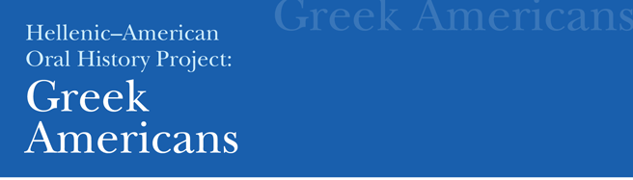

The Borough of Queens boasts the largest Greek American enclave in New York City—or anywhere else in the United States. So Queens College is the logical home for the Hellenic-American Oral History Project archive, which promotes understanding of Greek American communities in the metropolitan area and beyond.
This archive comprises five categories of statistics and information: qualitative data gleaned from our own growing library of oral histories; quantitative data drawn from the U.S. Census and other surveys; social science references; community data and resources; and published and unpublished texts about Greeks and Greek Americans. Data sets will be updated when they are officially accessible. We hope this material will be useful not only to researchers and policy makers, but also to anyone interested in Greek Americans.

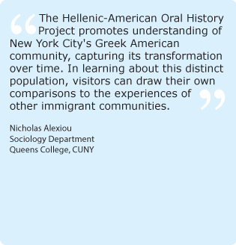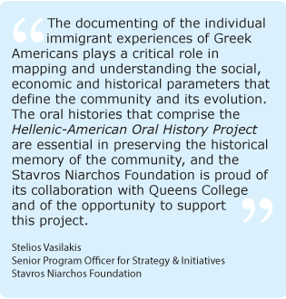

MEDIA COVERAGE
The Hellenic-American Oral History Project: Greek Americans, launched January 24, 2013.  Documenting the Greek Diaspora in Astoria, New York, the largest Hellenic-American community in the United States.  Television  NBC-TV “News 4 New York at 7,” Channel 161, February 21  New York-1 News, January 24  Greek News Channel, January 24  Radio  Dialogos Media Interview Series, May 24  Print  New York Daily News, January 25  “Tapping into untold stories of Greek immigrants”  New Queens College project archives the oral history of Greeks in New York City  Queens Gazette, March 27  “Queens College helps Greek Americans record their history”  Greek News Online/Greek News Greek-American Weekly, February 4  (and Ellines.com as a reprint)  “The Hellenic American Oral History Project at Queens College”  Times Ledger, February 1  “Queens studies Greek migration”  Queens Chronicle, January 31  “A spotlight on NYC’s Greek population”  Queens Ledger, January 29  “Greek immigrants in their own words”  Online  CUNY Media—City University of New York Social Media Production, March 27  Greek Reporter, USA, February 14  “Queens College keeps Greek archives”  Greek Reporter, USA, January 25  “Queens College records stories of Greek immigrants”  Voices of New York—City University of New York Journalism School  An association of the independent and ethnic press showcasing the best of the community and ethnic media. “An oral history of city’s Greeks”  Greek-Language Coverage  Television  Antenna TV, January 24  Radio  Dialogos Media Interview Series, May 24  Print  TO BHMA, 9 June 2013  Ιστορίες  Omogeneia.ana.gr, 14 February 2013  ΗΠΑ: Αρχείο για την Ομογένεια της Νέας Υόρκης στο Κολέγιο Κουίν  Κέρδος online, 14 February 2013  Αρχείο για την Ομογένεια της Νέας Υόρκης στο Κολέγιο Κουίνς  EΘΝΙΚΟΣ ΚΗΡΥΞ, 26 January 2013  Το Κουίνς Κόλετζ γράφει την ιστορία των Ελλήνων μεταναστών
  Office Information
  Bldg: Powdermaker Hall Room: 252c
  Phone: (718) 997-2826
  Fax: (718) 997-2820
  Nicholas Alexiou
  Sociology Department
  nicholas.alexiou@qc.cuny.edu
  Related Links
  Modern Greek Studies Association
  Greater Astoria Historical Society
  United States Census Bureau
  Next Generation Initiative
  Center for Byzantine & Modern Greek Studies
  NYC Census Tracts (PDF)
  An interview with Nicholas Alexiou


Μπασκόζος Γιάννης Ν.

Ιστορίες
ΔΗΜΟΣΙΕΥΣΗ: BHMA 09/06/2013 05:45
Μιλώντας με τον Νικόλα Αλεξίου, καθηγητή Κοινωνιολογίας στο Queens College της Νέας Υόρκης, μου επεσήμανε πόσο λίγα πράγματα ξέρουμε για τους Αμερικανούς-Ελληνες που εδώ και δεκαετίες βρίσκονται στη Νέα Υόρκη αλλά δεν έχει καταγραφεί συστηματικά ποτέ η ιστορία τους. Αγνοούμε προσωπικές ιστορίες που καταγράφουν την πορεία της ελληνοαμερικανικής κοινότητας, όπως αγνοούμε επίσης σημαντικούς ποιητές, πεζογράφους και καλλιτέχνες. Γνωρίζουμε ελάχιστους, κυρίως αυτούς που διέπρεψαν στον κινηματογράφο και βραβεύθηκαν κάποια στιγμή ή το έργο τους απέκτησε μια πρόσκαιρη δημοσιότητα. Δεν γνωρίζουμε όμως τον βίο τους, τις δυσκολίες, τα προβλήματα, τις μικρές επιτυχίες που τους έκαναν να δημιουργήσουν μια ισχυρή κοινότητα στην αμερικανική μητρόπολη αλλά και σε άλλες πόλεις των ΗΠΑ.
Την ημέρα που έφευγα από τη Νέα Υόρκη ο Ν. Αλεξίου κατέγραφε σε μια πολύωρη συνέντευξη τα προσωπικά βιώματα της Ιωάννας Καρατζαφέρη, πεζογράφου που έχει συνδέσει τη ζωή και το έργο της με τη Νέα Υόρκη. Η καταγραφή αυτή είναι μέρος ενός μακρόπνοου ερευνητικού σχεδίου που γίνεται στο πλαίσιο του τμήματος Κοινωνιολογίας του Queens College και το οποίο έχει στόχο να καταγράψει αναλυτικά την προφορική ιστορία των Ελληνοαμερικανών στη Νέα Υόρκη με σκοπό τη δημιουργία ενός Αρχείου Προφορικής Ιστορίας.
Το αρχείο αποτελείται από πέντε κατηγορίες στατιστικών στοιχείων και πληροφοριών: ποιοτικά δεδομένα που συγκεντρώθηκαν από τη δική του βιβλιοθήκη, στην οποία προστίθενται συνεχώς νέες προφορικές ιστορίες που συγκεντρώνει η ερευνητική του ομάδα. Ποσοτικά στοιχεία που προκύπτουν από την Υπηρεσία Απογραφής των ΗΠΑ και από άλλες έρευνες. Αλλες παρεμφερείς κοινωνικές έρευνες. Κοινοτικά δεδομένα και καταγραφή πόρων. Δημοσιευμένα και αδημοσίευτα κείμενα για τους Ελληνες στην Αμερική.
Ο ίδιος ελπίζει ότι το υλικό αυτό θα είναι χρήσιμο όχι μόνο για τους ερευνητές και τους φορείς χάραξης πολιτικής αλλά και για όποιον ενδιαφέρεται για τους Ελληνοαμερικανούς γενικότερα. Η ανάγκη μιας τέτοιας καταγραφής, πέρα από το γενικότερο ιστορικό ενδιαφέρον, έχει να κάνει και με το ότι οι γενιές που βρέθηκαν στις ΗΠΑ το τελευταίο μισό του προηγούμενου αιώνα αποχωρούν βιολογικά από τον κόσμο τούτο και μαζί τους χάνονται στοιχεία που δεν μεταβιβάζονται υποχρεωτικά στις επόμενες γενιές. Η δημιουργία προφορικών αρχείων, κάτι που στη χώρα μας έχει ιστορία μόλις δύο δεκαετιών, είναι πολύ χρήσιμη, καθώς καταγράφονται μαρτυρίες κοινωνικών ομάδων, συνήθως αποκλεισμένων από τα κέντρα εξουσίας, οι οποίες παραμένουν αφανείς, αν και βρίσκονται πολλές φορές πρωταγωνιστές ιστορικών γεγονότων.
-----------------------------------------------------------------------------------

ΕΦ. ΚΕΡΔΟΣ Κυριακή 30.4.2017

Αρχείο για την Ομογένεια της Νέας Υόρκης στο Κολέγιο Κουίνς
Από τότε που ο αείμνηστος μαχητής δημοσιογράφος της Ομογένειας Μπάμπης Μαλαφούρης, παρουσίασε το βιβλίο του «Έλληνες της Αμερικής 1528-1948», έχουν γίνει διάφορες προσπάθειες -αξιόλογες και μη- για την καταγραφή ιστορικών ντοκουμέντων που αφορούν τη νεοελληνική μετανάστευση στον «Νέο Κόσμο».
Με βάση το Κολέγιο Κουίνς του Δημοτικού Πανεπιστημίου της Νέας Υόρκης (CUNY) και με πρωτοβουλία του καθηγητή Κοινωνιολογίας Νίκου Αλεξίου, επιχειρείται -σε πρώτη φάση- να δημιουργηθεί αρχείο για την ιστορία των Ελλήνων στη μητροπολιτική περιοχή της Νέας Υόρκης.
«Βασικός μας στόχος είναι η αναζήτηση, διάσωση, ανάδειξη και προβολή στοιχείων και μαρτυριών για την ιστορική διαδρομή της Ομογένειας» δήλωσε στο ΑΠΕ-ΜΠΕ ο κ. Αλεξίου, σημειώνοντας ότι «μέχρι τώρα, στη Νέα Υόρκη δεν τελεσφόρησε καμία συζήτηση προς αυτή την κατεύθυνση».
Σε εκδήλωση που πραγματοποιήθηκε στο Κολέγιο Κουίνς, όπου βρίσκεται ο μεγαλύτερος αριθμός φοιτητών ελληνικής καταγωγής στην Αμερική, παρουσιάστηκαν οι στόχοι του προγράμματος. Ο κ. Αλεξίου επισήμανε ότι «έχουμε υποχρέωση να δημιουργήσουμε ένα αντιπροσωπευτικό και πλούσιο σε περιεχόμενο αρχείο για την ελληνοαμερικανική ιστορία, το οποίο θα αποτελεί σημείο αναφοράς και έρευνας γι' αυτό το μεγάλο κομμάτι του Ελληνισμού».
Ο Βολιώτης καθηγητής, που διδάσκει στο Κολέγιο Κουίνς για 24 χρόνια, με τη βοήθεια φοιτητών, ξεκίνησε εδώ και αρκετό καιρό μια μεγάλη έρευνα για να εντοπίσει και να συγκεντρώσει υλικό, τόσο με συνεντεύξεις και μαρτυρίες ομογενών, όσο και με αναζήτηση στοιχείων σε στατιστικές υπηρεσίες, κυβερνητικούς και ιδιωτικούς φορείς, καθώς και σε πανεπιστημιακά αρχεία.
Όπως εκτιμά, τα άτομα ελληνικής καταγωγής στη μητροπολιτική περιοχή της Νέας Υόρκης είναι γύρω στις 178.000 και στις ΗΠΑ περίπου 1,3 εκατομμύρια, προσθέτοντας ότι πλέον οι αμερικανογεννημένοι ομογενείς είναι περισσότεροι από τους ελληνογεννημένους.
Κατά τη διάρκεια της εκδήλωσης, εκτός από τον κ. Αλεξίου, μίλησε η πρόεδρος του Ελληνικού Φοιτητικού Συλλόγου «Ίκαρος», του Κολεγίου Κουίνς, Αλεξάνδρα Κάβουρα, η οποία είπε, μεταξύ άλλων, ότι «πρόκειται για μια σημαντική προσπάθεια που θα καταγράψει επιτέλους γνωστές και άγνωστες πτυχές της δικής μας ιστορίας».
Μεταξύ των παρισταμένων ήταν ο πρόεδρος και άλλα στελέχη του Κολλεγίου, ο γενικός πρόξενος της Ελλάδας στη Νέα Υόρκη Γιώργος Ηλιόπουλος, ο διευθυντής του Γραφείου Τύπου της Ελλάδας Νίκος Παπακωνσταντίνου και στελέχη ομογενειακών φορέων. Το έργο της αρχειοθέτησης στοιχείων για την Ομογένεια της αμερικανικής μεγαλούπολης χρηματοδοτεί το Ίδρυμα «Σταύρος Νιάρχος».
News Room «Κέρδος» με πληροφόρηση από το ΑΠΕ - ΑΜΠ
Εφημ. Κέρδος Κυριακή 30 Απριλίου 2017-04-30
------------------------------------------------------------------------

GREEK NEWS

The Hellenic American Oral History Project at Queens College
February 4th, 2013
Vicki James Yiannias
Chances to capture and document the lives and experiences of the “first wave” of Greek immigrants to the US, which began around 1880, have suffered the passage of time, but Queens College Sociology Professor Nicholas Alexiou, is bent on “capturing the moment before it is lost”, by documenting the “second wave” of Greek immigration to the U.S., 1960-1980, which has received little scholarly attention up to now, through his groundbreaking Queens College project, The Hellenic American Oral History Project: Greek Americans.
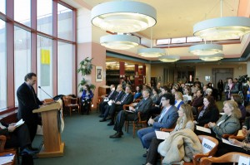The first-ever oral history archive of New York’s Greek American community and the changing face of Astoria, The Hellenic American Oral History Project: Greek Americans, made possible by major funding from the Stavros Niarchos Foundation, and part of a new Internet archive and research and database, features more than two dozen video interviews, in Greek and in English, of Greeks who emigrated to New York City between1960 and 1980 and their children.
At a press conference at Queens College of the City of New York in Flushing on January 24, where a multi-monitor display presented The Hellenic American Oral History Project’s more than two dozen oral history interviews, Professor Alexiou, Director of the project, expressed a motivation to document the largest Greek American community in the United States, saying, “The community does not know its own past, they need to know the people who created this community so there is a continuous link between the past and the present”.
We noted that while Greek American celebrities usually speak for Greek America in documentaries and in the media, this project offers a refreshing take, featuring a cross section of real people—business owners, civic leaders, students, and residents in Astoria, young and old, foreign and native-born Greek Americans–in Alexiou’s words, “the people who really created this community”.
Queens College has 1,500 students with Greek ancestry, more than any other American university, and its Center for Byzantine and Modern Greek Studies is the ideal place to host this archive that provides a groundbreaking perspective on the Greek American experience in New York.
Alexiou, who developed and carried out The Next Generation Initiative’s 2011 Got Greek? survey (based on his study The New Second Generation of Greek Americans, carried out at Queens College around the time of the Athens 2004 Olympics), has spent the last year conducting The Hellenic American Oral History Project interviews and drawing from U.S. Census data and other surveys, maps that reflect changing immigrant settlement patterns, demographics, and a historical overview of Greek immigration for depth of study. Additional funding would make more interviews possible.
Some statistics quoted at the press conference: there are about 1.3 million people of Greek ancestry in the U.S. and about 178,000 in the New York metropolitan area; the second wave of Greek immigration turned Astoria into the second largest Hellenic city outside of Athens. In recent years the number of US-born Greek Americans has exceeded the number of foreign-born as the members of that second wave of immigration have their own children. In New York, about 66% of Greek Americans were born in the US compared to 34% foreign born.
Speakers and the press conference were: Queens College President James Muyskens, Queens College Provost James Stellar, both of whom expressed admiration for the Greek community and support for and belief in the project, Georgios Iliopoulos, Consul General of Greece in New York, Alexia Makrigiannis standing in for Assemblywoman Aravella Simotas (a Queens College graduate), Stelios Vasilakis, Senior Program Officer for Strategy and Initiatives and Co-Chief of Public Affairs of the Stavros Niarchos Foundation, and oral history site participants Panos Adamopoulos, local businessman, and Alexandra Kavouras, Queens College student.
In his presentation, Stelios Vasilakis stated that “Queens College, which seats and serves one of the most ethnically diverse communities in America and Professor–and very good friend–Nicholas Alexiou–understand very well the importance of The Hellenic American Oral History Project for preserving the history of the Greek American community. In developing and supporting the project they have offered a tremendous service to the community… We are all very thankful to them. We at the Stavros Niarchos Foundation are very proud and very pleased not only to be here today, but to have been given the opportunity to support this very important project.”
Vasilakis pointed out that immigrant communities are “complex, dynamic, and ever-evolving”, and oral histories play an increasingly important role in the preservation and understanding of the social, political, and economic parameters of immigrant communities “as they go from one generation to the other”.
Two years ago he received support, not only in funding, but also in moral support, from the Stavros Niarchos Foundation, said Professor Alexiou, “I had proposed a two year project to the Foundation in which I would conduct interviews with Greek Americans in New York of different backgrounds in order to create a documentary portrait of ethnicity, identity and ethnic attachment. Today is the first step of the project as I had envisioned it: first, filming a number of interviews and creating a publicly accessible website based here at Queens College, a public institution, and eventually at some later point, to shape an interview constituted book. In the earliest stages Mr. Vasilakis was extremely supportive and enthusiastic, and when we first met with the Andreas from the Niarchos Foundation and with Mr. Stellar, [Queens College Provost], a Philhellene himself, who was also very supportive… and we are very thankful for that.”
Alexiou went on to say that at this stage of the research, although he is beset with the many and complex challenges of the project, he has realized, while going over the interviews these recent days, that the interviewees are telling a new story in a new way. “They are real people, with real individual and collective narratives. Over all, the
The Hellenic American Oral History Project, vis a vis the first-ever archive of the Greek Americans after one hundred years of continuous presence in New York, seeks to provide a groundbreaking perspective on the community and its experience.
He continued with observations on Astoria itself, saying, “Although Astoria is still the symbol of Greek immigration into the States, is not anymore the place where the Greek live. The Greeks, as they achieve socio-economic mobility, and neighborhood mobility, are moving out of Astoria, and part of this project is to depict that. You can see the maps based on the census that they still prefer Queens, though, places like Whitestone and Bayside. But the story that remains is simple. At this moment of transformation, of this transition of the community, the project comes at a good time.” Alexiou thanked the film director of the project, Tassos Rigopoulos and his team, one being filmmaker Mirto Kassis, “who is becoming more and more fanatic about getting more and more interviews… I hope that funds and good health will help us to continue.” He thanked the Chair of the Department of Sociology, the Dean of Social Sciences, and his colleagues from his Department and all the personnel, among others, who urged him to continue even on days when he was overcome with desperation,
“The latest wave was people looking for a better future, whether it was economic or educational… they came to the U.S. desperately seeking jobs to feed their families,” said Panos Adamopoulos, project interviewee. Turning the topic to the early immigrants, who founded Greek organizations, built schools and founded businesses, Adamopoulos, who is President of the Athenian Society of Astoria, noted that he later immigrants in the timeframe of the project were more easily assimilated into American culture and felt less need to belong to those cohesive cultural groups. He expressed the hope that Greek American youth will retain or recover interest in Greek cultural traditions to keep them alive.
To partake of this history in the making, go to www.qc.cuny.edu/greekoralhistory.
------------------------------------------------------------------

Queens studies Greek migration
By Rebecca Henely

Share on TwitterTweet
Share on Facebook
Bottom of Form
Like TimesLedger on Facebook.
Enlarge this image
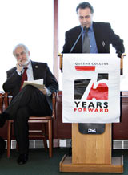
Photo by Rebecca Henely
Queens College sociology professor Nicholas Alexiou (r.) speaks about a project charting the immigration of Greeks to America from the 1960s to the '80s. Photo by Rebecca Henely
Top of Form

Bottom of Form
As an institution with a large Greek-American student population in a borough with the largest Greek enclave in New York, Queens College unveiled the first part of an ongoing research project last week that is aimed at filling a gap in the study of the Greek diaspora.
Sociology professor Nicholas Alexiou said at a news conference at the college, at 65-30 Kissena Blvd. in Kew Gardens Hills, that while the largest influx of Greeks to America came during the Great Migration at the beginning of the 20th century, there was a second, smaller wave of people who came between the 1960s and the ’80s that has been largely unresearched.
“I saw the gap in Greek-American studies,” Alexiou said.
The Hellenic-American Oral History Project, which can be viewed online at qc.cuny.edu/greekoralhistory, features 23 filmed interviews with Greek immigrants and American-born Greeks, as well as another page of research with demographics, maps and census data that charts Greek immigration to America.
“I have realized that the informants, the interviewees, are telling a new story in a new way,” Alexiou said.
Queens College has an extensive Greek studies program, with some classes taught in Greek, and the borough is the home to Astoria, one of the biggest Greek enclaves in America.
Panos Adamopoulos, president of the Athenian Society of Astoria and one of the interviewees, said in the period spanning the 1960s to the ’80s, Greeks came to America not to flee hardship at home but because they were more cosmopolitan and immigration was easier.
But they also were less interested in joining local Greek organizations like earlier immigrants.
“I believe a lot of things have been gained, but a lot of things were lost as well,” Adamopoulos said.
Alexiou also spoke about how the Greek-American community has achieved economic mobility. While many still move to Astoria, many are branching out into Whitestone, Bayside and the greater suburbs.
The project was conceived by Alexiou two years ago, with interviews being conducted in the last year, and made possible through a grant from the Stavros Niarchos Foundation.
“I think it’s very, very important and a huge gift to the Greek-American community,” Stelios Vasilakis said about the foundation, which gives grants to a multitude of education, health, social welfare and arts projects in Greece and in the diaspora. “I think it’s very important for the next generation to look back and see what are the experiences of the previous generation.”
Alexiou said the publicly available website is the first step of the project, with the ultimate goal of interpreting the collected data from the interviews and turning the findings into a book.
“I’m really proud of this project,” said Alexia Makrigiannis, a staffer of state Assemblywoman Aravella Simotas (D-Astoria) and a former Queens College student. “It really shows our students here at Queens College what we’re all about.”
Reach reporter Rebecca Henely by e-mail at rhenely@cnglocal.com or by phone at 718-260-4564.
Posted 9:02 pm, January 31, 2013
-------------------------------------------------------------------------------

Bottom of Form

Greek immigrants in their own words
by Andrew Pavia
Jan 29, 2013 | 4047 views | 0 | 10 | |
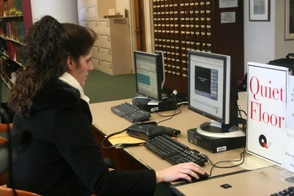
Katerina Hantzandreou , one of the participants of the Hellenic-American Oral History Project, looking at her own interview for the first time.

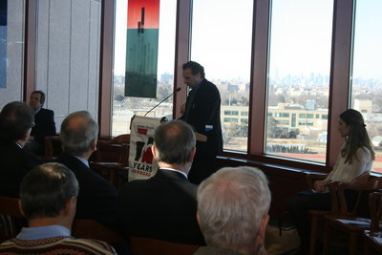
Nicholas Alexious, Queens College professor and director of the Hellenic-American Oral History Project
The history of Greek immigrants told in their own words is now live.
The Hellenic-American Oral History Project features 23 Greek immigrants who share their stories in both English and Greek. The videos tell the tales of Greek-Americans who left Greece between 1960 and 1980, known as “second wave” immigrants.
This second wave of immigrants actually changed the cultural landscape of Queens, as Astoria become home to the most Greeks outside of Athens.
The project at Queens College was funded with grant money from the Starvros Niarchos Foundation. The videos are available at www.qc.cuny.edu.
Nicholas Alexious, Queens College professor and director of the Hellenic-American Oral History Project, said that he came up with the idea about a year ago.
“They opened their heart, and that isn’t an easy thing,” he said, adding that their stories give continuity to the Greek community at a moment of transition.
Alexious said there is a gap that exists when it comes to the history of Greek immigration to the United States. Today, there are roughly 1.3 million people of Greek ancestry in the U.S. and about 178,000 of them in the New York City area.
Interviewees reflected a wide range of viewpoints and backgrounds to ensure that the stories and experiences tell a complete story. Alexious said he would like to add even more testimonials in the future if the funding can be found.
Katerina Hantzandreou, a sociology professor at Queens College, took part in the project.
=============================================

Hantzandreou’s family immigrated from Greece in the 1970’s, landing in Delaware to live with family until they moved to New York City seeking more opportunities.
She said that immigrants from Greece are proud of their roots. Hantzandreou said that many of the Greek immigrants she knows and their children still speak Greek and attend a Greek-Orthodox church.
“This will affect all kinds of students because we all have an ethnic background and some people are raised to have a strong affiliation with their cultural background, and those who were not exposed to that might take it into consideration,” she said. “We should all be exposed to it and take pride in it.”
Read more: Queens Ledger - Greek immigrants in their own words
===========================================================

February 8, 2013, by VOICES OF NEW YORK,

Source: Greek News

An Oral History of City’s Greeks
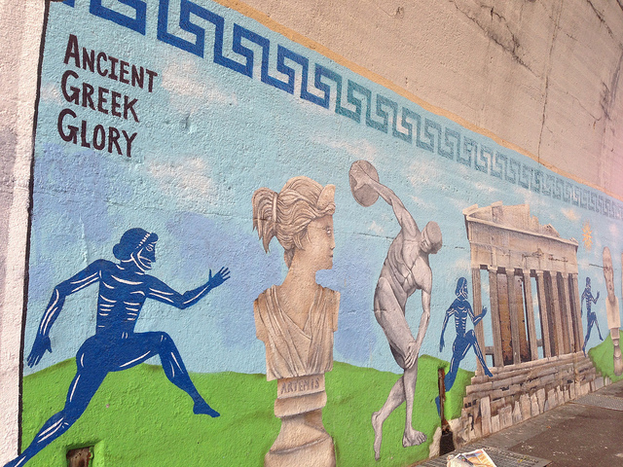
Street mural in Astoria, Queens. (Photo by Daniel Bentley, Flickr Creative Commons License)
The first-ever oral history archive of New York’s Greek-American community is a Queens College project that seeks to document Greek immigration to the U.S. from 1960 to 1980, Greek News reports.
The article, by Vicki James Yiannias, points out that “The Hellenic American Oral History Project: Greek Americans” also documents the changing face of Astoria.
Chances to capture and document the lives and experiences of the “first wave” of Greek immigrants to the U.S., which began around 1880, have suffered the passage of time, but Queens College Sociology Professor Nicholas Alexiou, is bent on “capturing the moment before it is lost,” by documenting the “second wave” of Greek immigration to the U.S., 1960-1980, which has received little scholarly attention up to now.
The project, funded by the Stavros Niarchos Foundation, is part of a new Internet archive and research and database. It features video interviews, in Greek and English, of Greeks who emigrated to New York City between 1960 and 1980 and their children.
At a press conference at Queens College of the City of New York in Flushing on January 24, where a multi-monitor display presented The Hellenic American Oral History Project’s more than two dozen oral history interviews, Professor Alexiou, Director of the project, expressed a motivation to document the largest Greek American community in the United States, saying, “The community does not know its own past, they need to know the people who created this community so there is a continuous link between the past and the present.”
The article notes that Queens College has 1,500 students of Greek ancestry, more than any other American university. Its Center for Byzantine and Modern Greek Studies will host the archive.
Some statistics quoted at the press conference: there are about 1.3 million people of Greek ancestry in the U.S. and about 178,000 in the New York metropolitan area; the second wave of Greek immigration turned Astoria into the second largest Hellenic city outside of Athens. In recent years the number of U.S.-born Greek Americans has exceeded the number of foreign-born as the members of that second wave of immigration have their own children. In New York, about 66% of Greek Americans were born in the U.S. compared to 34% foreign born.
Alexiou said the archive is the first step of a project that he hopes to turn into a book.
He continued with observations on Astoria itself, saying, “Although Astoria is still the symbol of Greek immigration into the States, is not anymore the place where the Greek live. The Greeks, as they achieve socio-economic mobility, and neighborhood mobility, are moving out of Astoria, and part of this project is to depict that. You can see the maps based on the census that they still prefer Queens, though in places like Whitestone and Bayside. But the story that remains is simple. At this moment of transformation, of this transition of the community, the project comes at a good time.”
For more information or to participate in the project, visit: www.qc.cuny.edu/greekoralhistory.
Tags: Astoria, Greeks, Nicholas Alexiou, oral history, Queens College
=================================

